Name: Ryan Woodward
Student ID : 100201137

Database server: http://ec2-54-158-196-73.compute-1.amazonaws.com/phpmyadmin/
Login : s2014_user1
Password : s2014_user1

Database : sampdb

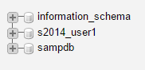

Click

Part A – use the table PET [2 marks each]
- Write a SQL statement to display all columns of all rows of PET.

- SELECT * FROM PET

Sample output.

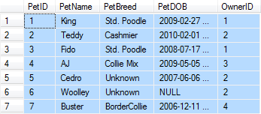

- Write a SQL statement to display the breed and type of all pets.

Sample output
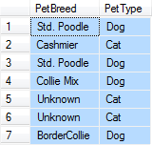
SELECT PetBreed, PetType FROM PET

- Write a SQL statement to display the breed, type, and DOB of all pets having the type Dog.

Sample output
Select PetBreed, PetType, PetDOB FROM PET
WHERE PetType=‘Dog’;
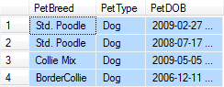

- Write an SQL statement to display the PetBreed column of PET.

Sample output

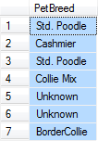
SELECT PetBreed FROM PET
- Write a SQL statement to display the PetBreed column of PET. Do not show duplicates.
Try to research on the keyword “distinct”
Sample output
SELECT DISTINCT PetBreed FROM PET
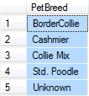

- Write a SQL statement to display the breed, type, and DOB for all pets having the type Dog and the breed Std. Poodle.

Sample output
SELECT PetType, PetBreed FROM PET
WHERE PetType=’Dog’ AND PetBreed=’Std. Poodle’
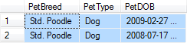

- Write a SQL statement to display the name, breed, and type for all pets that are not of type Cat, Dog, or Fish.

Sample output

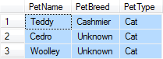
SELECT PetName, PetBreed, PetType FROM PET
WHERE PetType NOT IN (‘Cat’,’Dog’,’Fish’)

- Write an SQL statement to display the Pet ID, breed, and type for all pets having a four-character name starting with K.
SELECT PetID, PetName PetBreed, PetType FROM PET
WHERE PetName LIKE ’K???’
Sample output


- Write an SQL statement to display the last name, first name and email of any owner who has a NULL value for OwnerPhone.

Sample output
SELECT LastName, FirstName, Email FROM EMPLOYEE
WHERE Phone IS NULL

- Write an SQL statement to display the name and breed of all pets sorted by PetName.
Sample output
SELECT PetName, PetBreed FROM PET
ORDER BY PetName

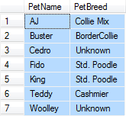
- Write a SQL statement to display the name and breed of all pets sorted by PetBreed in ascending order and by PetName in descending order within PetBreed.

Sample output
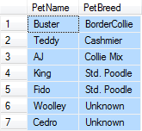
SELECT PetName, PetBreed FROM PET
ORDER BY PetName ASC, PetBreed DESC

- Write an SQL statement to count the number of pets.
Sample output
SELECT COUNT(*) AS NumberOfPets FROM PET
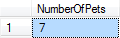

- Write an SQL statement to count the number of distinct breeds.
Sample output

SELECT COUNT(DISTINCT PetBreed) AS NumberOfBreeds FROM PET

Part B – use the table PET_3
- Write an SQL statement to display the minimum, maximum, and average weight of dogs.

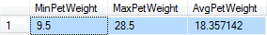
SELECT MIN(PetWeight), MAX(PetWeight), AVG(PetWeight) FROM PET_3

- Write an SQL statement to group the data by PetBreed and display the average Weight per breed.
SELECT PetBreed, AVG(PetWeight) FROM PET_3
GROUP BY PetBreed
